THE WAY of LOVE Vacation Bible School for Children - Outline

THEME – THE WAY of LOVE, based on Bishop Curry’s practices for a Jesus-centered life.
GOALS – To: TURN – PRAY – WORSHIP – BLESS – GO – REST
HOW? – With: music, gardening, hiking, labyrinth, Bible study, arts & crafts, snacks, and Chapel.

Divide the children into varying groups by age.

Schedule: Four activities a day per group, three-and-a-half hours a day four days a week. On the last day during Chapel family members join in. (Maybe celebrate with a meal afterwards.)

Morning schedule – 8:30 – 12:00 or Afternoon schedule 4:00 – 7:30.

[Nativity Church Note: We ended up with only 12 children (thank you Covid), creating only 2 groups. We cut back to 3 days and decided on an evening VBS starting at 5:00 and ending at 7:30. And we continued to have all but arts & crafts activities outside (no need for masks). Also, instead of scheduling snack time, we decided to serve a light dinner for the children and their families at 5:00. (All food was pre-packaged.) Our volunteer staff was amazing. We had four teenagers, age 14 – 17 volunteer. Two assisted the group leaders, one in each group; and the oldest two volunteered as the arts & craft leaders for the whole group. We had an additional 12-14 adults to volunteer at least once during the VBS. This included 2 group leaders/shepherds, 2 activity leaders, hiking/gardening, and labyrinth-we are fortunate to have a paved path meandering around our church campus, a large labyrinth on the property and four raised garden beds that needed lots of attention), 3 volunteers in the kitchen, and 4 other adults who helped with set-up, clean-up and some days stayed around to help where needed. The rector was in charge of the singing before the activities and Chapel time at the end of the day. He also volunteered at the last minute to lead the labyrinth activity, which was a treat. As director I greeted each of the children, checking them in and was available to everyone throughout the week.]

VBS – THE WAY of LOVE Planning

- I met with the Formation Team to suggest the idea as well as introduce them to THE WAY of LOVE. After approval, we began promoting the VBS during church and on the church Facebook page. This meeting began in April with the idea of a July VBS date. [See THE WAY of LOVE lessons from Bishop Curry, pg.3]
- I met a second time with the Formation Team to work on the budget. I also gave each member of the Team a set of lessons for each word in the path as it related to our VBS. [See THE WAY of LOVE VBS lessons, pg. 5-6]
- I made a final schedule for each day that fit the needs of our church. The children and families ate dinner as they arrived, Afterwards the children met at the outdoor sanctuary for singing with the rector; then Group One went to one activity; and Group Two went to another activity. Then both groups had a Bible study separately. Next each group rotated the daily activity. The next two days two new activities were introduced. Each day the arts & crafts activities coincided with the other activities. [See Daily Activity Schedule Example, pg. 7]
- Preparation and acquiring supplies was next. (Nativity Note: We are a small church, however we budgeted $350. As the director I assumed responsibility for preparation and getting the supplies. I was able to delegate some things like asking the Needlers, our sewing group, to make the bandana tote bags for each child.) [See Supply List Example, pg. 8]
- Planned the Training Session for all the volunteers along with the rector. We informed all involved of this training date which was planned far enough in advance that everyone would be prepared and familiar with THE WAY of LOVE path. The rector prepared the Bible study lessons and gave them to the two group leaders in advance. At the training I handed out what I had given the Formation Team including Bishop Curry’s invitation, the schedule of each day, and examples of the arts & crafts that related to each activity. (Nativity Church Notes: One day the first group scheduled to go hiking had to hike around the inside of the church because of unexpected rain. The sun was out by the time the second group was scheduled to hike. We had a Plan B in place of rain for all activities.)
- First Day – Each child was given a bandana tote bag filled with a mini-notebook, package of tissues, and a mechanical pencil. The children picked out a foam visor, ordered online, which we used as their name tag, and a tag chain necklace which I made. (Nativity Church Note: I bought the large multi-colored bandana’s from Amazon, rope cord form the craft store, and gave a sewn example to the ladies in our church Needlers group that meet once a week to sew together in the Parish Hall. They made over 24 bags which allowed us for surprise registrants and teenage and adult volunteers who wanted a bag. I used card stock and printed enough tags of each WORD, then cut them, punched a hole and strung them on the chain that I ordered online.)
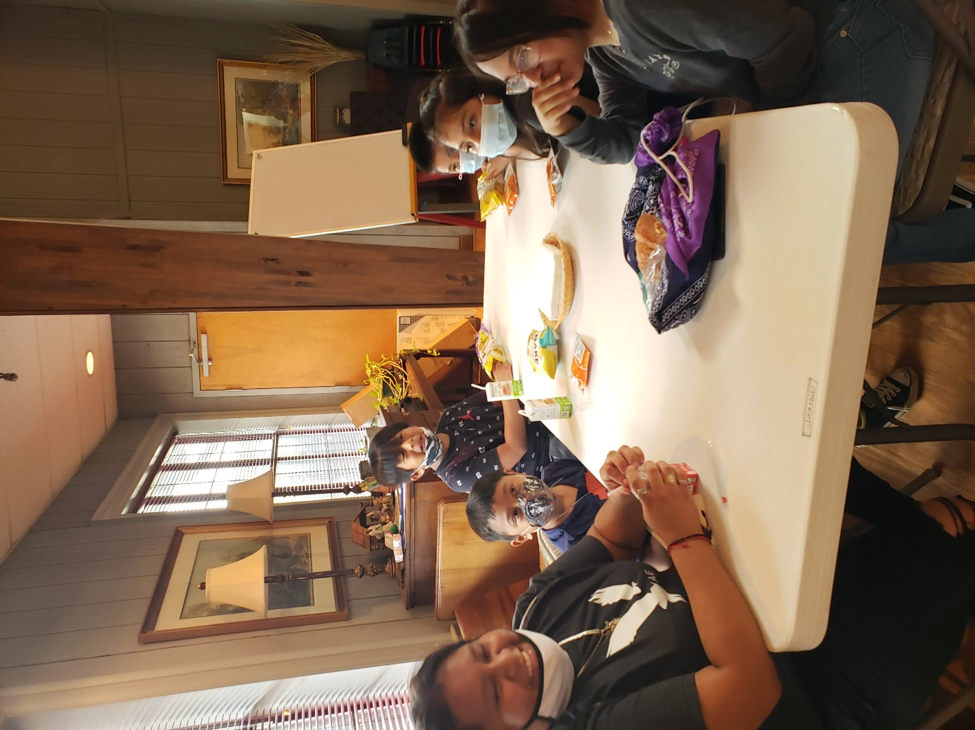
Example of the Bandana Tote bags pictured here during dinner/snack time.

Invitation from Presiding Bishop Michael Curry to practice the Way of Love, practices for a Jesus-Centered life.
“The Way of Love is a way of life. More than a program or curriculum, it is an intentional commitment to a set of practices. It is a commitment to follow Jesus: TURN, LEARN, PRAY, WORSHIP, BLESS, GO, REST.”
TURN – Figure out how can I every day turn my life like a flower turning toward the sun, to turn my life in the direction of God, in the direction of Jesus.
LEARN – Every day, what can I learn from the Word of God through reading of scripture, reading of through spiritual materials that help to train up the spirit, if you will, but to wrestle and to live with scripture paying particular attention to those passages and teachings where we actually hear the voice of Jesus.
PRAY – To spend time every day, some real time praying. It doesn’t have to be long, but some real time in prayer. And there are practices in prayer and different ways of prayer that help us in that journey.
WORSHIP – To gather in Christian community at least once a week; preferably for the Holy Eucharist if possible. To gather for worship as a community where we are with other followers of Jesus; where we can worship our God; open our lives to God; and be blessed by God and by each other. Jesus said, “Wherever two or three are gather together in my name, there I am in the midst of them.”
BLESS – Somebody once said we have been blessed so we might be a blessing. To each day, make a decision: I’m going to live my life as a blessing. And at every turn in that day and every moment of decisions, ask, how can I be a blessing, in this day, in this way, in this moment?
GO – To go into the world and touch somebody’s life. To go into the world and love the way Jesus did; to give the way Jesus gives; to forgive the way Jesus forgives; to do justice, love mercy, and walk humbly with God like Jesus.
TURN, LEARN, PRAY, WORSHIP, BLESS, GO and then…..
REST – It is not an accident hat the seventh day of creation in the book of Genesis where God saw all that God had made and God rested. The soul must rest; the Spirit must rest. If God rested? Who are we not to?

The Way of Love Lessons for VBS

TURN – Pause, listen and choose to follow Jesus.
From Bishop Curry: Like the disciples, we are called by Jesus to follow the Way of Love. With God’s help, we can turn from the powers of sin, hatred, fear, injustice, and oppression toward the way of truth, love, hope, justice, and freedom. In turning, we reorient our lives to Jesus Christ, falling in love again, again, and again.
Where do we see TURN active in our VBS? – By learning the Lord’s Prayer and saying it each day, the children can turn toward things that bring them closer to Jesus. This can be done hiking, gardening, during Bible Study, at Chapel, singing, during Arts and Crafts, and sharing snacks together.
LEARN – The purpose is to reflect on the Scripture every day, especially on Jesus’ life and teachings. Focus: Say the prayer our Lord taught us, every day so that by the end of the week each child is not only familiar with it but may even have it memorized.
From Bishop Curry: By reading and reflecting on Scripture, especially the life and teachings of Jesus, we draw nearer to God and God’s Word dwells in us. When we open our minds and hearts to Scripture, we learn to see God’s story and God’s activity in everyday life.
Where do we see LEARN active in our VBS? – Every day during the Bible Study time. Each group will read scripture related to Jesus’ LOVE (which will be provided), reflect on it by sharing a story (also provided), discuss what it means to the children, close with a prayer of gratitude for hearing God’s message. The lessons will reflect the age group intended.
PRAY – This is one way we dwell intentionally with God on a daily basis.
From Bishop Curry: Jesus teaches us to come before God with humble hearts, boldly offering our thanksgivings and concerns to God or simply listening for God’s voice in our lives, and in the world. Whether in thought, word or deed, individually or corporately, when we pray, we invite and dwell in God’s loving presence.
Where do we see PRAY active in our VBS? – Each day: at the end of the gathering time before we separate into groups; at the end of our Bible study time; before we have our snacks; and at the beginning and closing of the Chapel time.
WORSHIP – We gather in community weekly to thank, praise, and dwell with God.
From Bishop Curry: When we worship, we gather with others before God. We hear the Good News of Jesus Christ.
Where do we see WORSHIP active in our VBS? – During our hiking activity we will see God’s creations in the beauty of the world outside. Then during our daily walk in the Labyrinth, we will center our thoughts on Christ and repeat, “Be still and know that I am God.” Psalm 46:10 as we walk in silence. Also, while we are working in the Garden, we will praise God and give thanks for the beauty and bounty that surrounds us. And finally, every day as we end the day we will worship together in the Chapel.
BLESS – This means to share our faith and give and serve unselfishly to others.
From Bishop Curry: When we incorporate the practice of blessing others into our lives, we are putting our love into action by becoming the Good News for others.
Where do we see BLESS active in our VBS? – We give back to Nativity by weeding the gardens; we forgive by being patient and kind to our friends; we teach by creating signs for the garden and by naming plants in the garden and by building a “wisdom box” during arts & crafts for the church; we heal our souls as we walk the Labyrinth learning to be present and mindful; and finally we sing at the beginning of the day, on the hiking trail and at the end of the day during Chapel.
GO – This means to cross boundaries, listen deeply and live like Jesus!
From Bishop Curry: We go to become a Beloved Community, a people reconciled in love with God and one another.
Where do we see GO active in our VBS? – We go each day we leave Nativity Church. And when we go, we take with us what we have experienced and learned and we become examples of Jesus.
REST – Here we receive the gift of God’s grace, peace and restoration.
From Bishop Curry: From the beginning of creation, God has established the sacred pattern of going and returning, labor and rest. Especially today, God invites us to dedicate time for restoration and wholeness – within our bodies, minds, and souls, and within our communities and institutions. By resting we place our trust in God, the primary actor who brings all things to their fullness.
Where do we see REST active in our VBS? – When we leave the last day, we will celebrate with our families, friends and other church members. The children leave filled with joy, peace and great memories. The staff leave filled with love for their charges, peace, and pride for was accomplished. Everyone leaves with the love of God.

Daily Schedule:
4:45 – 5:30 – Dinner – Parrish Hall. A pre-packaged meal for children and volunteers. EVERYONE will sign in at this time at the Registration Table.

5:30 – 5:45 – Activity Leaders and Shepherds head to their assigned areas while the children and his support team go to the outdoor chapel for songs.

5:45 – 6:15 – Shepherds collect their group at the outdoor chapel and go to their first activity. Shepherds and helpers stay with their groups.
- Monday– Older Group to Hiking; Younger Group to Arts & Crafts
- Tuesday – Younger Group to Arts & Crafts; Older Group to the Gardens
- Wednesday – Older Group to the Labyrinth; Younger Group to Arts & Crafts

6:15 – 6:45 – Both Groups have Bible Study at their home base tents.

6:45 – 7:15 – Groups go to the second activity. Shepherds and helpers stay with their group.
- Monday – Older Group goes to Arts & Crafts; Younger Group to Hiking
- Tuesday – Younger Group goes to the Gardens; Older Group to Arts & Crafts
- Wednesday – Older Group goes to Arts & Crafts; Younger Group to the Labyrinth.

7:15 – 7:30 – Chapel Time. EVERONE, all children and volunteers meet at the outdoor worship area for Chapel with Fr. Jason.

7:30 – Dismissal and Clean-up.

Supplies*
Groups:
Four tents
Church table and chairs or sit-upons, or camp chairs
Tote bag for each group leader with wipes, hand sanitizer, extra sunscreen, clip board, pen, marker, and a list of each child in the group. (+possible other items)
Bible Study materials
The Very Best Day, THE WAY of LOVE for Children by Roger Hutchison, from Church Publishing

Hiking:
Compass for each child – found online
Set of rules – “Leave No Trace.” – made poster and printed instructions with the activity leader
Water bottles for leaders and children (bring from home with name on it.)
Small pocket notebooks and pencils for each child – found at Dollar Tree
Sturdy shoes (canvas or hiking) no sandals (child supplies)
Sunscreen and sun hat or visor – we provided the visor, the children the rest

Gardening:
Garden gloves
Hand shovels (on loan from church members)
Sun hats and sunscreen (Child provides)
Garden hose – on church property

Labyrinth:
Individual lap cards - online

Arts and Crafts:
Tables
Plastic Tablecloths – Dollar Tree
Acrylic paints - online
Paint brushes - online
Permanent Markers in Assorted colors – craft store
Bird Houses – ordered online
Wood signs for the gardens – ordered wooden spoons online
Scissors, masking tape, extra paint brushes – Sunday School supplies
Glue Gun – brought from home

Snacks:
Juice boxes and/or Capri Sun drinks
Napkins
Trash bags
Variety of snacks like Trail Mix, fruit, veggies, etc. (Avoid sweets) – ready-made sandwiches were provided with healthy chips.

*All supplies will be provided by the church unless otherwise noted.

Daily Schedule

Day One Hiking– begins with a suggestion for the group leaders to set the tone all three days. Even if they don’t read it out loud, it will be in their minds throughout the day. Give each leader their supplies which included a trash bag, rubber gloves, a “Leave No Trace” Rule poster and rules. On the first day the groups hiked around the church property on a paved trail. (Nativity Church Note: I talked with the volunteer for all three activities well in advance and she was excited to incorporate THE WAY of LOVE throughout the day in whatever activity she was leading. Remember we had only two groups, one ages 4-7 and one ages 9-12, not three. During Arts & Crafts the children weaved yarn around stick stars, which I used a glue gun to make ahead of time, they painted wooden birdhouses to keep, and painted wooden spoons to use as markers in the garden.) [See picture examples, pg. 17-19]

Day Two Gardening – After following directions for start of the activity, the activity leader with the about five other volunteers spent their time weeding beds, planning flowers and/or vegetables, and laughing a lot. It was a true BLESSING. Supplies include fresh plants, sunflower seeds, garden tools, garden gloves and beach towels to place around the raised beds. (Nativity Church Note: church members that were not able to volunteer donated the seeds, flowers and rubber gloves. The rest other volunteers provided from their own gardens at home.) [See picture examples, pg. 17-19]

Day Three Labyrinth – (Nativity Church Note: We have a beautiful full-size labyrinth on our church campus. The Plan B for rain for this activity were individual lap labyrinth cards that I ordered online. One for each child to keep. If you don’t have access to a Labyrinth, then these cards would work as well. The purpose of this activity is to become mindful of the things around us and REST in God’s love.)

Hiking/Gardening/Labyrinth Lessons

Day One - Hiking
Hiking/Gardening/Labyrinth Activity Leader: You will repeat this three times today, once to each group.
Say: Today we are going to hike around the church grounds. We will use this time to look at and explore the beauty of God’s earth and all that we see. As we walk, we will think about Jesus’ love for us and try to see that His love for us is big and deep. As we take our hike, we will use a chart to check off things we see along the path. All these things are gifts from God, and we will begin to see them with gratefulness in our hearts. Each of you will be given a tote bag which has in it a small notebook and pen to make notes or draw pictures you see on our hike. Also in your bag are some tissues, your chart, a compass, and “Leave No Trace” notecards.
Read the Leave No Trace Rules:
- Bring trash bags. (Explain that you will have a trash bag in your tote bag and rubber gloves and that if trash is found, the children will NOT pick it up, but tell one of the leaders who will use the rubber gloves and pick it up.)
- Stick to the trail. (Explain that the path goes all the way around the church, and it is important to not wander off into the woods or leave the trail or pass up the leader in the front of the line or go back behind the leader at the end of the line.)
- Leave what you find. (Explain that we do NOT pick flowers, pick up sticks, rocks, or other growing objects on the trail. If you see a fallen leaf, acorn, and want to pick it up, that is okay, but ask a leader first.)
- Plan ahead. (Explain that it took planning and time to prepare for this hike around the church which the VBS staff did ahead of time. This includes the tote bags and supplies inside.)
- Respect other visitors on the trail. (Explain that you may not be the only group on the trail and if you come across someone you stop and quietly pass them or say excuse me.)
- Respect the wildlife. (Explain that we do not disturb birds, squirrels, or other wildlife. The leaders need to keep an eye out for snakes. The trail should be clear of fallen logs or anything blocking your path.)
Time to take your hike: Pass out the tote bags to each child and begin your walk. (If a child needs to use the restroom, gets hurt, or absolutely needs to stop the activity, one of the Group Leaders can bring them to the VBS Director and return to their group as soon as possible.)
While on the hike: Point out these things as you walk. Stop occasionally to point out:
- God’s creativity – in the wonderful variety in the natural world such as the vast array of birds…insects…mammals…trees…flowers.
- God’s strength – in the tree trunks and branches that provide shade. Also, mountains and waterfalls not far from our home (Lookout Mountain.)
- God’s love of beauty – in the tiny flowers along the path, moss growing on the trees (north side, use your compasses), and vines hanging from the trees.
- God’s attention to detail – in that each bird is different, each leaf is different. “Nothing in all creation is hidden from God.” (Hebrews 4:13)
- God’s tenacity – in that God is with us all the time, right where we are. “I can never escape from Your Spirit! I can never get away from Your presence!” (Psalm 139:7)
When you return to your starting point, say: Close your eyes and listen with your hearts. The Way of Love is through Jesus Christ who lives in each of us. You have seen God’s beauty in the path around our church, all the living plants, the earth, the tiny animals, the sun, the clouds, and the sky. Now GO and live like Jesus, remembering what you learned today. Amen

Day Two - Gardening
Hiking/Gardening/Labyrinth Activity Leader: You will repeat this three times today, once to each group.
When a group arrives, say: Welcome to God’s Garden! We have several beds that need our tender care. We are going to break into small groups help to make these gardens beautiful. (You will be provided with garden tools, gloves and seeds to help the children week the beds.) We LEARN new things when we are awake and even when we are sleeping. Just like us, our gardens need help growing. As we pull weeds and plant seeds, we are BLESSING our time in the garden. God gives us the sun, earth and rain and we grow food to eat and food to share with others. Today is a growing day.
You should have enough help to separate the children to different garden beds. (We will have your supplies and things the children will need ready for each group.)
Allow for time at the end of the period to gather materials for the next group and so that the children can go inside the church to wash their hands.
Say a closing prayer: Close your eyes and listen with your hearts. Thank you, God, for reminding us that you give to us freely and now it is up to us to give back and do as Jesus would do. Help us to remember that The Way of Love is our path to a way of life. Amen

Day Three Labyrinth:
Hiking/Gardening/Labyrinth Activity Leader: You will repeat this three times today, once to each group.
When a group arrives at the starting point of the Labyrinth. Welcome them with a sense of quiet and peace. Then walk around the Labyrinth pointing out the design. When you get back to the front as the children to sit down and to take out their notebook and pen. (Beach towels and/or quilts will be provided.)
Say: Draw a picture or write a word that describes any worries you have. Are you sad, hungry, tired, hot, or worried about someone. You can also write down the name of someone you want to send love to. Or if you have a secret word from your Bible Study lesson today, you can use that word. No one is going to see what you draw or write. (The activity leader can guide each child in one at a time, while his/her assistant greets them at the center and tells them what to do before going back out.)
Typically one child should go at a time, but if a group is large and there is not enough time two could go at a time, but remind them to not talk but either think of the note in their pocket or hand.
When the children have completed this task, ask them to fold up their note and put it in a pocket or hold it in their hand. Then say together: “Be still and know that I am God,” from Psalm 46:10. Explain that they will walk the path in silence thinking about their notes and when each child reaches the center they are to stop. If they focused on worries, they are to tear up their piece of paper and throw it in the trash. If they focused on sending love to someone, they are to imagine that love is like a balloon and picture it floating away filled with energy. If they just simply relaxed as they moved toward the center, tell them to make a wish and smile.
When all the children have made their way back to the outside of the Labyrinth, remind them that they do not need a Labyrinth to pray. God is with us all the time.
Say: Rest within your heart and soul with God, your friend who loves you.
Before the children go to their next activity, collect any trash from torn up notes.

Bible Lessons – Each group was asked to stay at their “home” station during this time.

Monday Bible Lesson for Group Leaders – Begin with making sure everyone is sitting down and quiet.
Read: Scripture Text: Ephesians 3:17-19: International Children’s Bible: Read or let a child read: “I pray that Christ will live in your hearts because of your faith. I pray that your life will be strong in love and be built on love. And I pray that you and all God’s holy people will have the power to understand the greatness of Christ’s love. I pray that you can understand how wide and how long and how high and how deep that love is. Christ’s love is greater than any person can ever know. But I pray that you will be able to know that love. Then you can be filled with the fullness of God.”
Say: The Word of God and the children respond: Thanks be to God.
Explain the theme for the week: The theme our VBS is The Way of Love, a practice written by our Bishop Curry on centering our lives in Christ. This means putting Jesus first in our life and thinking about what He would do before we do it. Each day we will find ways to TURN, LEARN, PRAY, WORSHIP, BLESS, GO, and REST.
Say the Lord’s Prayer, one line at a time, with the children repeating each line. (Everyone will have a prayer card to follow from. Hopefully, by Thursday each child who does not already know this by heart, will.
Go to your activity.

Tuesday Bible Lesson for Group Leaders: Begin with making sure everyone is sitting down and quiet.
Read: Scripture Text: “Freely you have received; freely give.” – Matthew 10:8
Say: The Word of God and the children respond: Thanks be to God
Explain Today’s Theme: Jesus called his disciples to give, forgive, teach, and heal in his name. We are empowered by the Spirit to BLESS everyone we meet, practicing generosity and compassion and proclaiming the Good News of God in Christ with hopeful words and selfless actions. (You may have to explain what generosity and compassion mean depending on what age group you are working with.) Remind them that like the disciples, we are all supposed to be giving in our words and actions. Whether we are at school, at church, on the playground, or in our gardens, we are always LEARNING. Jesus teaches us that we have received such gifts and it is for us to choose to give back.
Say the Lord’s Prayer, one line at a time, with the children repeating each line. (Everyone will have a prayer card to follow from. Hopefully, by Thursday each child who does not already know this by heart, will.
Go to your next activity.

Wednesday Bible Lessons for Group Leaders: Begin with making sure everyone is sitting down and quiet.
Read the Scripture Text: “Be still and know that I am God.” – Psalm 46:10
Explain today’s theme: In every heart there is God’s kingdom, a holy place to pray. Our soul is the home of God inside us, each and every day. The Way of Love teaches us to PRAY and we can do this together as a group, alone, in church, and even outdoors. Today we are focusing on Centering Prayer.
Lesson: Read the book, “Journey to the Heart.” This book should take about ten minutes to read as it also has a lesson in centering prayer. While the book says to let the children stay in silence for 7 minutes, this may be too long for some children. Maybe take just a minute or two for the time of silence. Step 7 in the book is to say the Lord’s Prayer. As this is the last day, try saying it all together at this time.
Go to your next activity.

The Way of Love for Children – Staff Gathering
Monday: Holy Habits and the Way of Love
Scripture Text: Ephesians 3:17-19: “I ask that Christ will live in your hearts through faith. As a result of having strong roots in love, I ask that you have will have the power to grasp love’s width and length, height and depth, together with all believers. I ask that you will know the love of Christ that is beyond knowledge so that you will be filled entirely with the fullness of God.
Theme for the day: How do we see God in our roles this week? What habits are part of our VBS? How to these habits shape us as individuals, and how can we as individuals shape our VBS as a whole? What role do Prayer, Learn, Bless and Worship play in our lives?
Other announcements. We encourage the leaders to remain with the groups throughout the day. That means participating in each activity.
Book of Common Prayer (BCP) Text: “Strengthen [us], O Lord...with your Holy Spirit; empower us for your service; and sustain us all the days of our lives.” (p 418)
Tuesday: The Way of Love is a Way of Life - Share faith and unselfishly give and serve.
Scripture Text: “Freely you have received; freely give.” – Matthew 10:8: Jesus called his disciples to give, forgive, teach, and heal in his name. We are empowered by the Spirit to bless everyone we meet, practicing generosity and compassion and proclaiming the Good News of God in Christ with hopeful words and selfless actions. We can share our stories of blessing and invite others to the Way of Love.
Theme for the day: What are the ways that Spirit is calling us as we do God’s work? How do you see us practicing a Jesus-centered lift? Look for signs that all we do as a result of the Way of Love is freely given to us and it can be freely built upon.
Other announcements.
Book of Common Prayer (BCP): Celebrant: Will you proclaim by word and example the Good News of God in Christ? People: We will, with God’s help. – Book of Common Prayer, (p 305)
Wednesday: The Way of Love is an invitation to the whole church - Cross boundaries, listen deeply and live like Jesus.
Scripture Text: Jesus said to them again, "Peace be with you. As the Father has sent me, so I send you."– John 20:21 - As Jesus went to the highways and byways, he sends us beyond our circles and comfort, to witness to the love, justice, and truth of God with our lips and with our lives. We go to listen with humility and to join God in healing a hurting world. We go to become Beloved Community, a people reconciled in love with God and one another.

Theme for the day: What do you imagine is God’s dream for us today at VBS? How will the adults and the children respond to the call to GO forth to live as Jesus lived? After today ends, in what ways can we continue to instill The Way of Love in our community at Church of the Nativity?

Other announcements.

"Send them into the world in witness to your love." – Book of Common Prayer (306)
Arts & Crafts

Day One - Arts & Crafts
- Paint birdhouses to keep or share outside the church.
- Paint garden signs
Day Two – Arts & Crafts
- Finish painting birdhouses & garden signs
- Leaf Threading - The smells, sights, and textures of an activity like this provides a sensory rich experience that children can find quite absorbing.
Day Three – Arts & Crafts
- Star Stick Mobiles for the outside Chapel
- Finish any project not complete.

Extra Activities for those in-between-times: Lord’s Prayer Bookmark (online) and the WAY of LOVE catcher from forma. [See Picture Examples, pg. 17-19]

Picture Examples
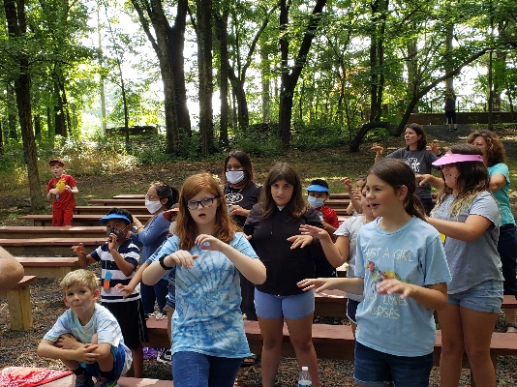
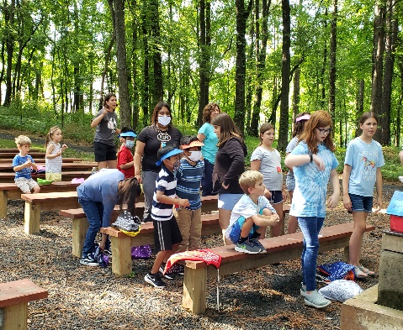
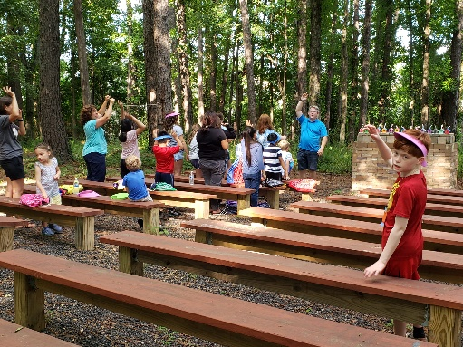
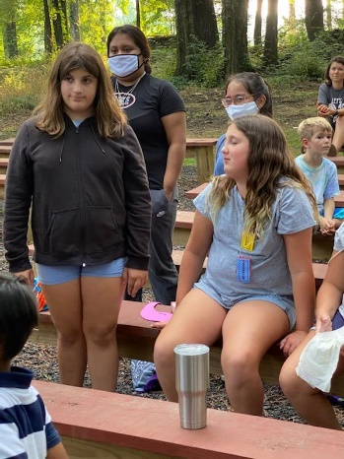
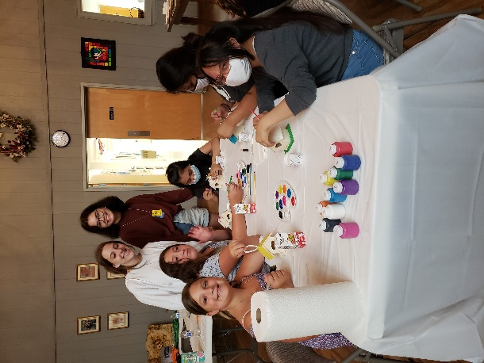
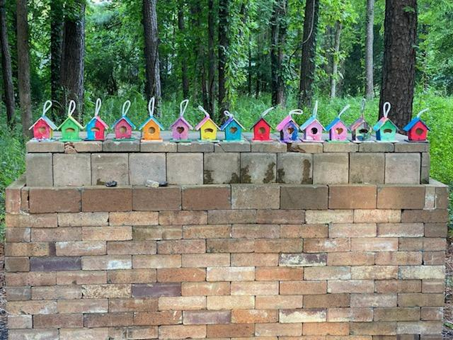
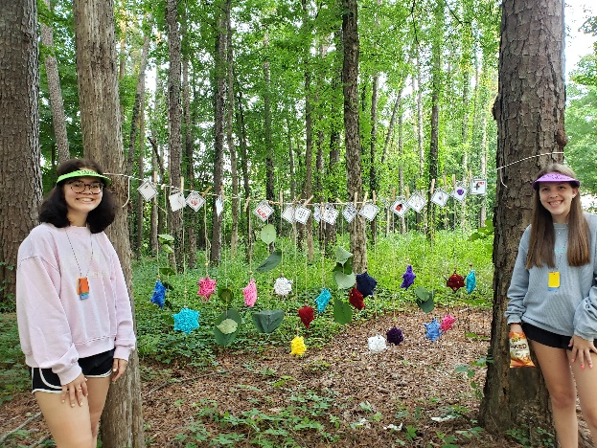

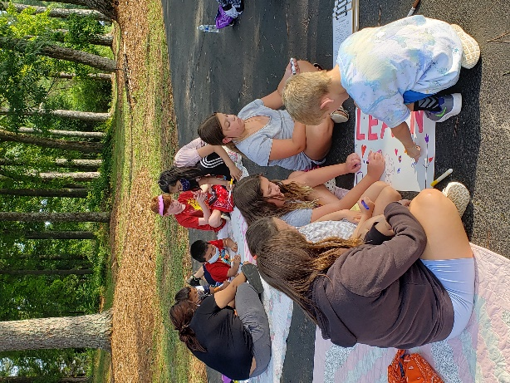
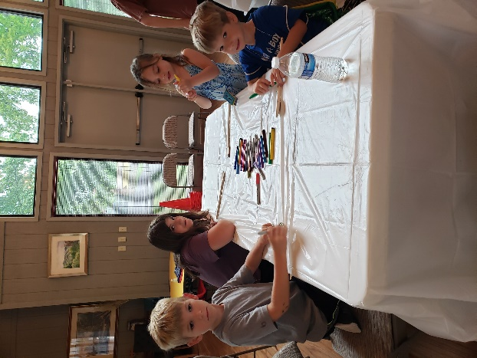

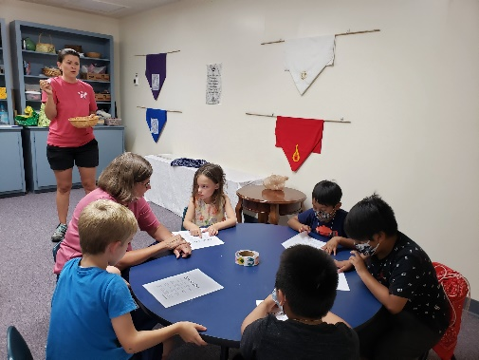
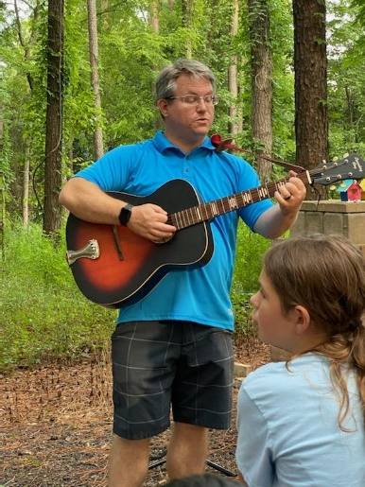
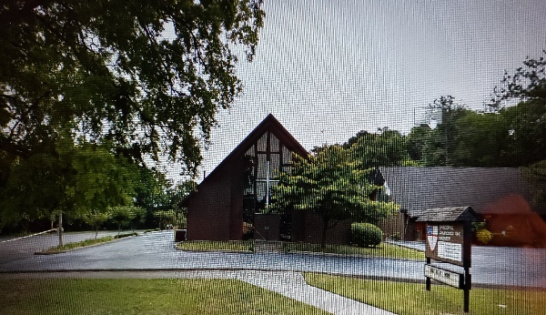
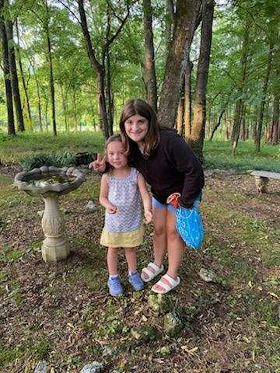
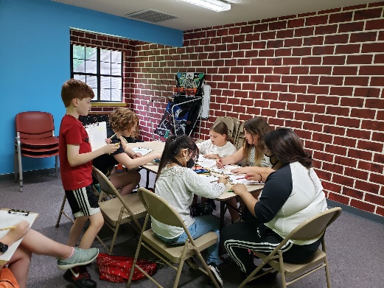
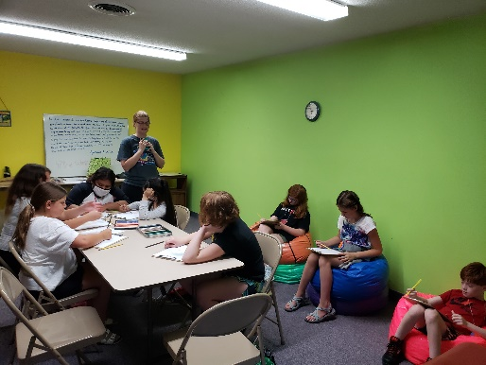

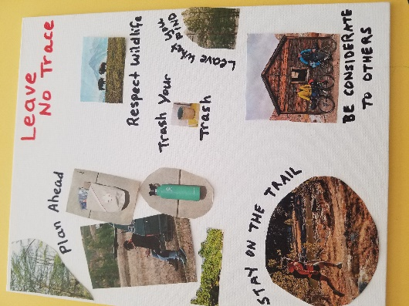
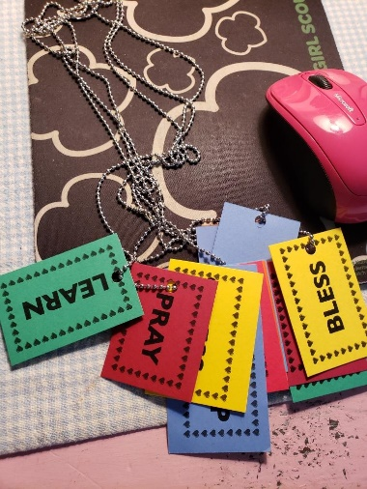
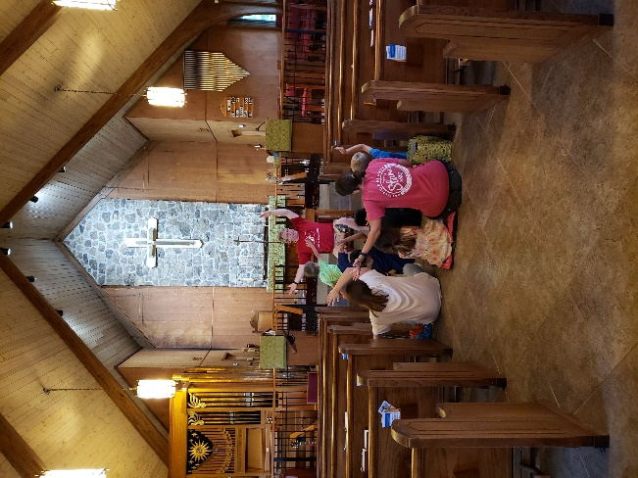

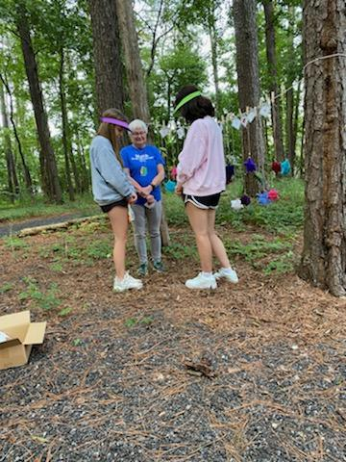
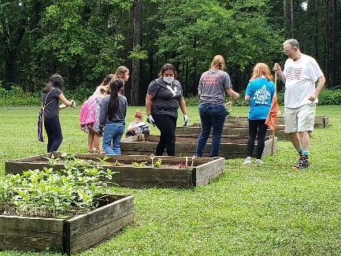
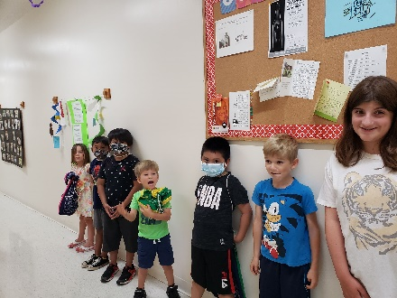
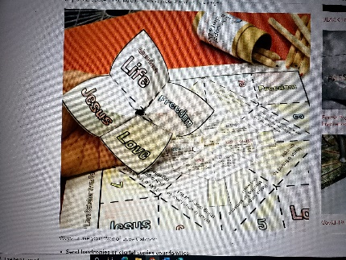
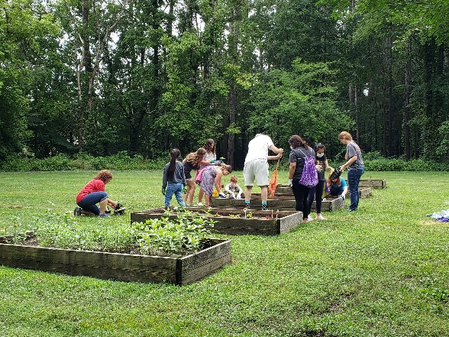

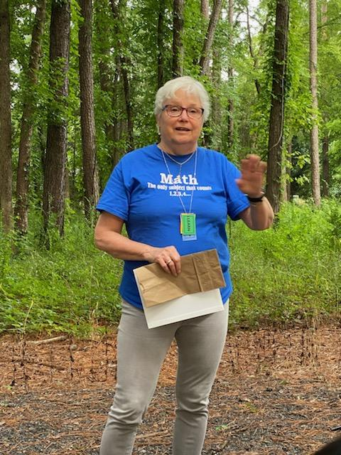

Closing Remarks: Writing this curriculum was an amazing experience. It came to me overnight and so I believe it came from God. I had been trying to wrap my head around something I could do share my gifts with my new church and a VBS seemed the answer. I am most grateful to the Formation Team for welcoming me into this venture. I had spent quite a bit of time listening to and watching THE WAY of LOVE videos from the website. I feel that I live so God can live and therefore everything I do has a purpose. I don’t always know what or why, but I follow my inner wisdom to the paths that I am led. For now, I have been appointed to the Vestry for the first time and after participating in the 2022 Annual INVITE, WELCOME, CONNECT Gathering, I am hoping to help our church parish make a concerted effort to follow this path along with Bishop Curry’s path to follow Jesus.

Priscilla N. Shartle
Nativity Church, Ft. Oglethorpe, GA
March 2022

